**University of Southern California**

Viterbi School of Engineering

CSCI 599: Content Detection and Analysis for Big Data

**Instructor**:Dr. Chris Mattmann

Assignment 2: Scientific Content Enrichment in the Text Retrieval Conference (TREC) Polar

Dynamic Domain Dataset

**TEAM 22**

**GitHub repository**: *http://www.github.com/harshfatepuria/ Scientific-Content-Enrichment-in-the-Text-Retrieval-Conference-TREC-Polar-Dynamic-Domain-Dataset*

**Github.io website**: [*http://harshfatepuria.github.io*](http://harshfatepuria.github.io)

*(All the visualizations with interactive capabilities available on this website)*

Date: 04/04/2016

Report submitted by:

Harsh Fatepuria, *fatepuri@usc.edu*

Warut Roadrungwasinkul, *roadrung@usc.edu*

Rahul Agrawal, *rahulagr@usc.edu*

(Graduate Students, Department of Computer Science)

1. **Common Codes for all the following Parsers**
2. **TikaExtractedTextBasedParser**: An abstract class extended from Tika AbstractParser. Parsers that perform on text extracted from documents using Tika should extend this class. This class also provide a method to get extracted text from a document. Most of the parsers created in this assignment extend this class.
3. **AbstractParserRunner**: A utility class to run a specific parser using all the documents in a specified folder. It can be configured through different parameters. Start parsing by invoking runParser() method.

|  |  |
| --- | --- |
| baseFolder | base folder of documents to be parsed |
| resultFolder | base folder to keep result files |
| markerFile | marker, for skipping the files that are already been parsed |
| overwriteResult | set to overwrite existing results (default : false) |
| documentsInCborFormat | setting that tell whether documents to be parsed are in CBOR Format, for parsing data in common-crawl (default : false). CBOR support can be used separately using cbor.CborReader |

1. **Tag Ratio Tika Parser and Measurement Extractor**
2. Apache Tika was to convert files in the dataset into an intermediate XHTML file. Then, the Text-To-Tag ratio for the file was calculated using the formula: **No of text characters in the line/ No of tags in a line**. The overall TTR is the average of the TTR for individual lines in a file. The irrelevant text where the TTR is lesser than the average TTR ratio is discarded. Only the remaining text is chosen for next stage (measurement analysis).
3. The code to perform this is in the class TTR.TTRAnalysis. It is also wrapped as a Tika parser, measurement.TagRatioParser, and can be used separately.
4. Next, a wrapper class was created (wrapped in measurement.MeasurementParser), which utilized this parser’s text extraction capabilities to extract measurement based data from the files. We developed an algorithm for extracting the measurements, which is outlined below:
5. Extract text using Text-to-Tag ratio analysis
6. Tokenize text using Stanford CoreNLP DocumentPreprocessor
7. Extract number using Stanford CoreNLP NumberNormalizer
8. Concatenate consecutive text tokens that can be normalized to number, these tokens normally are part of the same number so they should be treat as a whole, reevaluate the text.
9. Extract numbers and their 2 following tokens
10. For each extracted 3-gram, match tokens with Unit concepts defined in SWEET Ontology (reprSciUnits.owl) and some predefined symbols. The two tokens will be match separately and combined using both exact and fuzzy string matching. Concepts that are within tolerance will be considered a measurement
11. Output measurement (unit) and its number (magnitude).

Algorithm 1: Extract Measurements from documents

1. To run this across the dataset, initialized measurement.MeasurementParserRunner and provide its parameters then invoke runParser() method or invoke the main class with following parameters.

**java** main.Main -t **measurement** -b *baseFolder* -r *resultFolder* [-m *markerFile*] [-cbor]

1. Sample measurements extracted by the parser using the above algorithm are:

|  |
| --- |
|  |
| year 296930 |
| kilometre 151741 |
| degrees 135431 |
| hour 107379 |
| kelvin 79598 |
|  |

Snippet 1: A Sample of Extracted measurements with their counts

1. **URL Shortner**
2. In order to give unique short identities to each files, YOURLS (Your Own URL Shortner), an open source tool was used. Each file in the TREC Polar Dataset was mapped to a unique 8-character long alphanumeric hash. The resulting key-value pairs were stored as JSON objects containing the file path and the short URL.
3. A sample JSON containing the short URL and relative file path is shown below:

{"metadata":

{

"filePath": “org/aoncadis/www/96DEB8E3B9… CA50B668CAB77D03392AC7F4A790670706662D030",

"shortURL": "polar.usc.edu/2acb03f4"

}}

Snippet 2: Example snippet showing mapping between filePath and shortURL

1. These JSON files are dumped along with outputs from other parsers developed as a part of this project into the solr index. This helps us in identifying and retrieving a file using its shortened URL.
2. **Content Extraction and NER using Grobid Journal Parser**
3. Grobid Journal Parser in Tika was used to extract TEI annotations from the PDF files in the dataset.
4. Out of roughly forty five thousand such PDF files, majority of them were either truncated or image files stored in PDF format. Grobid Journal Parser gives exceptions on such files, and we ignore such files for the purpose of this project. Furthermore we only consider the files containing title and abstract fields in their TEI information to retrieve a rich set of documents in the following steps.
5. For each of the PDF files in the dataset, their TEI annotations are stored as JSON data.
6. Next, the scholar.py program was used to pull 20 related publications for each of the PDF files above. Since there is a limit of requests that can be made using the API, not all publications were pulled.
7. Relevant information such as Authors, Publication Year, and Affiliations were extracted and identified for each of the new papers/ journals.
8. NOTE: Fields used for extraction of papers- To extract the most relevant publications, we used its title and keywords from abstract. We used stop words list to ignore the irrelevant words.
9. **Geo-Topic Parsing using Tika GeoTopicParser**
10. The Tika GeoTopic Parser allows us to extract location related content from the files. A program to run this parser on the entire dataset was developed. The GeoParser class is already defined. We wrap it in our GeoWrapperParser so it can accept every type of documents that are supported by Tika. This parser will extract GeoName, Latitude and Longitude as metadata, along with optional locations.
11. To run this across the dataset, after running the Geo Gazetteer server, initialized geoparser.GeoParserRunner and provide its parameters then invoke runParser() method or invoke the main class with following parameters.

**java** main.Main -t **geo** -b *baseFolder* -r *resultFolder* [-m *markerFile*] [-cbor]

1. The results obtained were stored as JSON objects. A sample result file is shown below:

{ "metadata": {

"Geographic_LONGITUDE": [ "-86.73611" ], "Geographic_NAME": [ "Medium United Methodist Church" ],

"Geographic_LATITUDE": [ "35.26341" ], filePath": [ "aero/weather/982DA6E97F400……………..……A406" ]

}}

Snippet 3: Sample result from GeoTopic Parsing

1. Later, these output files were dumped in solr to generate an inverted index.
2. **Intersecting the above results with SWEET**
3. Semantic Web for Earth and Environment Terminology (SWEET) contains 600 files with Environment related terminologies. These annotations were intersected with the results obtained from GeoTopic Parsing to extract relevant environment related data.
4. SWEET Ontologies are written in OWL format. We use **Sesame** (rdf4j.org) as an engine to store and query these ontologies. We create and store this repository within sweet.SweetOntology class. The class also provide methods for querying the concept by fuzzy string matching using Levenshtein Distance provided by Apache Commons library.
5. Wrapped in sweet.SweetParser, SWEET concepts extraction can be done by the following steps.
6. Perform Named Entity Recognition to extract entities using Stanford CoreNLPNERecogniser
7. For each extracted entities, match these entities with SWEET concepts. Select the best matched concept that the distance is within tolerance
8. To run this across the dataset, initialized sweet.SweetParserRunner and provide its parameters then invoke runParser() method or invoke the main class with following parameters.

**java** main.Main -t **sweet** -b *baseFolder* -r *resultFolder* [-m *markerFile*] [-cbor]

1. Implication: (Step V) ∩ (Step VI) gives us the extracted environment related terms form all the files in the dataset. Sample results are shown below:

http://sweet.jpl.nasa.gov/2.3/realm.owl#Earth 133751

http://sweet.jpl.nasa.gov/2.3/matrSediment.owl#Boulder 50560

http://sweet.jpl.nasa.gov/2.3/matrCompound.owl#CO 18179

http://sweet.jpl.nasa.gov/2.3/realmOceanFeature.owl#SouthernOcean 14449

Snippet 4: SWEET ontology intersected with Extracted Dataset and extracted counts

1. A brief summary of extracted metadata types on the dataset with the number of files are shown below:

|  |  |  |
| --- | --- | --- |
| **Metadata Type** | **No. of files** | **No. of files with metadata** |
| Measurement | 1360304 | 370284 |
| Geo | 641653 | 268763 |
| SWEET | 1360313 | 348741 |
| Grobid | 37810 (PDF) | 1711 |

Table 1: Number of files used for our analysis

1. **Metadata Quality Store**
2. **Inverted Index Generation using Apache Solr**
3. Technology Used: Apache Solr.

Reasons for choosing Solr over Elastic Search: Solr is slower, yet more powerful as compared to Elastic Search. Also,

MEMEX GeoParser is easier to connect to Solr index.

1. A program/ script to iterate over all the extracted or parsed content was developed. The program ingests the output JSON files into the index. However, the rate of ingestion is very slow.
2. The proposed schema for Solr to represent our data is present in the file Schema.xml present in the submission folder.
3. Explanation of what fields are important to visualize, and what are important to search and to find the data
4. **MEMEX GeoParser**
5. The MEMEX GeoParser is run over the index generated by us in the last step (VIII) from the GeoTopicParser. The location map hence generated is shown below:

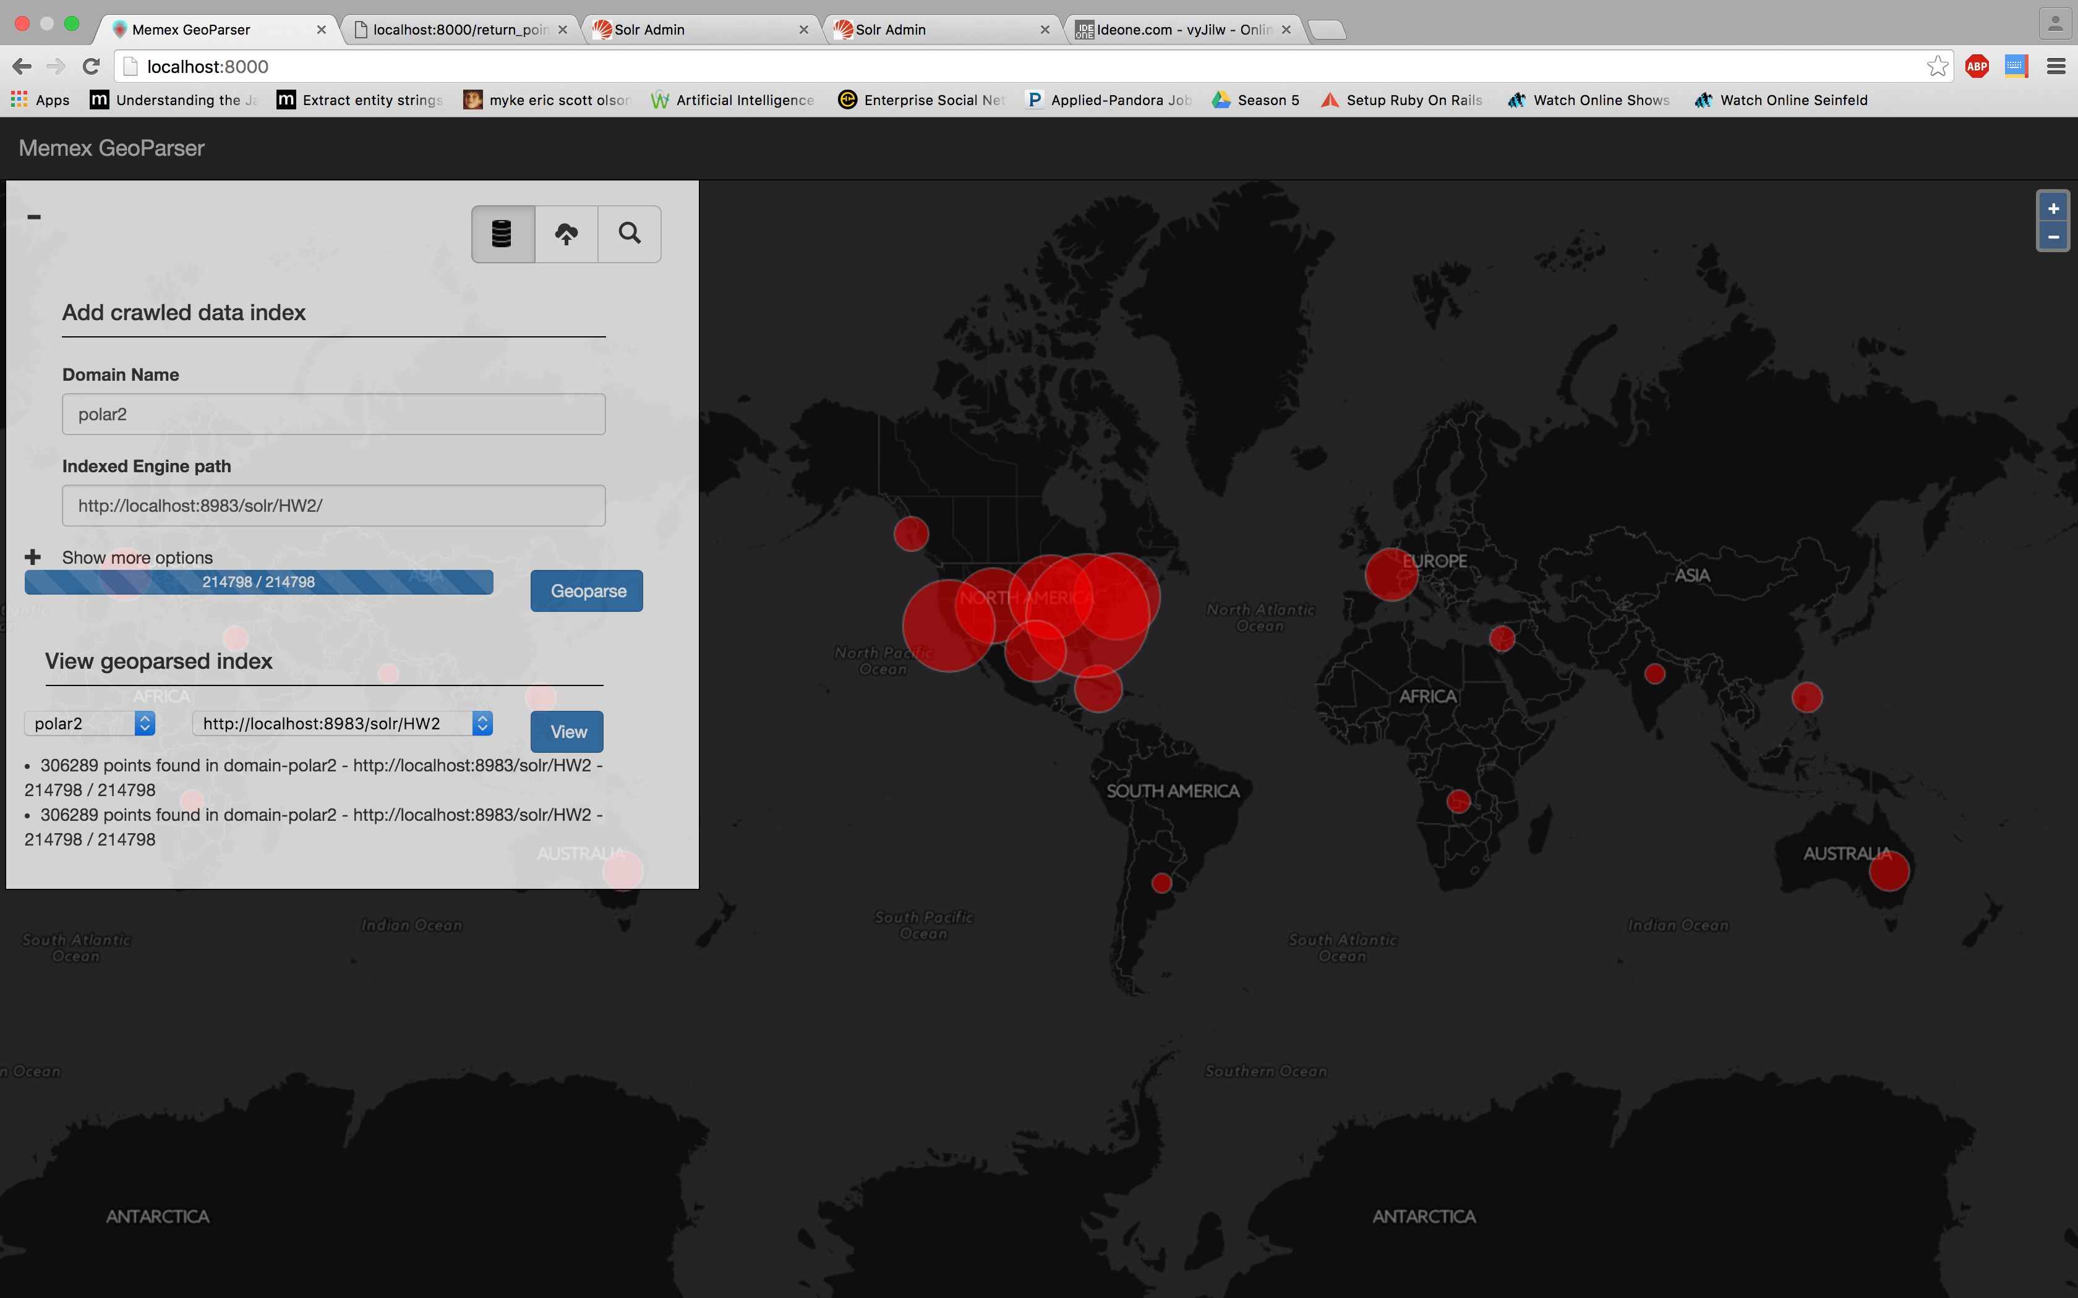

Fig 1: MEMEX GeoParser result

1. A snippet of the Solr Index containing the above data is shown below:

{

"points":["[{'loc_name': 'RepublicofIndia', 'position': {'y': '79.0', 'x': '22.0'}}]"],

"id":"7e889d67-d25b-4e22-90cd-d47962999e7a",

"_version_":1530476767183110144

}

Snippet 5: Solr Index. MEMEX GeoParser used to generate the world map shown above

1. **Tika Similarity**
2. From assignment 1, we had already modified codes in tika-similarity to support clustering using cosine distance and edit distance. In this assignment, we will modify the codes to be able to represent Solr index of each extracted metadata type by extending existing Vector class and clustering them using specific distance measure.
3. For measurement extraction, we create MeasurementVector class. It will store extracted measurement units and its average magnitude. We will use Cosine Distance to cluster this.
4. For related publication and author, we create GrobidVector class. It will store only authors and related publications information. Since this data are mostly string based, we will use Edit Distance to cluster this.
5. For extracted locations, we create GeoVector class. It will store extracted latitude and longitude. Since these values are points in 2-D space, we will use Euclidean Distance to cluster this.
6. For SWEET features, we create SweetVector class. It will store set of extracted SWEET features. Since these values are parts of a finite set (all SWEET concepts), we will use Jaccard Similarity to cluster this.

We will use K-mean as a clustering algorithm. We will cluster a sample set of documents that are ingested to Solr index. The set contains documents in /gov/nasa/climate in polar-fulldump dataset which are about 1200 files but when extracted there will be around 300 files for each metadata type. For related publication and author we will use another set of documents extracted from various folder which are around 45 files.

To select number of clusters (k), we will run the clustering with number of clusters vary from 2 to 10. We then plot normalized distortion value and select number of cluster by Elbow method. Selected number of cluster for measurement, related publication and author, locations and SWEET concepts are 6, 4, 5 and 4 respectively.

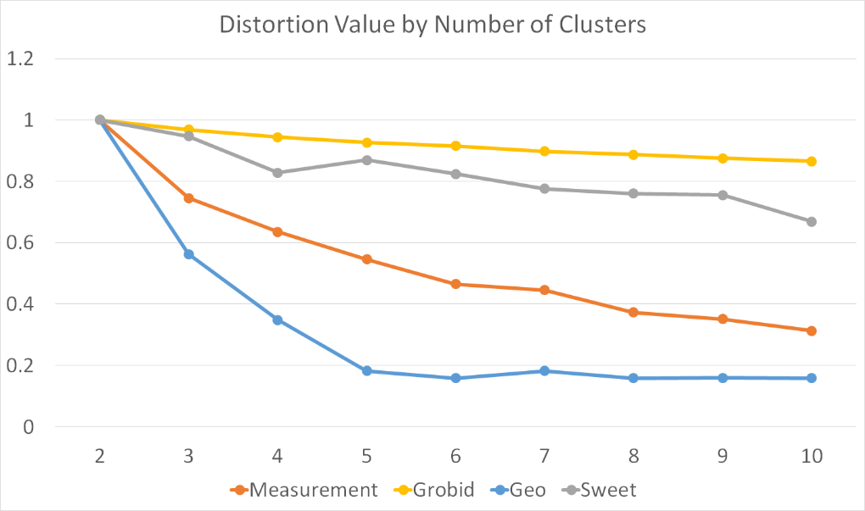

Fig 2: Tika Similarity Results- Distortion Values v/s Number of Clusters for various parsers

Clusters visualizations are located in tika-similarity/result folder. The code can be executed using the following command: python **solr_metadata_cluster.py** *type*(measurement|grobid|geo|sweet) *solrUrl noOfCluster*

Or, execute this command for sample results: python **solr_metadata_cluster.py** sample

1. **D3 visualizations**
2. Website for viewing the visualizations: [*http://harshfatepuria.github.io*](http://harshfatepuria.github.io)
3. The following D3 visualizations represent our extracted features and some analysis on them using the parsers developed throughout the past month.

|  |  |
| --- | --- |
| **Visualization** | **Explanation** |
| * 1. SWEET Concept | Gives a count analysis on the extracted SWEET terms from the text. Restricted to top 100 results. File Name: sweetOntologyCountBarChart.html |
| * 1. Grobid + Google Scholar | A dendogram of publications with authors and authors of related publications. Helped in finding overlap between authors in related publications. File Name: relatedPublicationsDendogram.html |
| * 1. Metadata Score Analysis | Gives a visual representation of Metadata score based on number of fields present. The larger the circle, the higher the score. File Name: metadataScoreCirclePacking.html |
| * 1. Measurement Extraction | Gives a count analysis of various types of measurement terminologies extracted from the data. File Name: measurementCountBarChart.html |
| * 1. Geo Location Analysis | Gives an analysis of various locations extracted from the dataset. File Name: geoLocationCountPieChart.html |
| * 1. Geo Location Clustering | Clustering based on locations on a world map. File: geoLocationCluster.html |

Table 2: List of D3 visualizations

1. These visualizations are dynamic and connect to our solr index. We have contributed our web pages as pull request to polar.usc.edu as well.
2. **[Extra Credit] Connecting GeoParser Application to actual data in Solr Index**
3. We connected the GeoParser application to the actual data in the solr index. Furthermore, we developed a Geo Location map which shows extracted location metadata upon hovering.

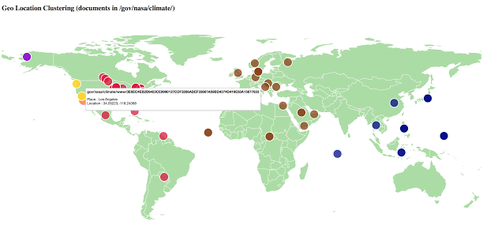

Fig 3: Metadata visualization over world map on hovering

1. **[Extra Credit] Feature/ Content Extraction using Tesseract OCR**
2. There are many image files in the polar dataset. These files may contain valuable information in the form of embedded text. Using Tesseract OCR, Tika will be able to extract text embedded in various types of image. By installing Tesseract OCR library, Tika will use it automatically when parsing files with supported types in combination with other parsers.
3. We developed tesseract.TesseractOCRParserRunner which is a utility class to run string parsing across image files with supported types. To run it, initialized TesseractOCRParserRunner and provide its parameters then invoke runParser() method or invoke the main class with following parameters.

**java** main.Main -t **ocr** -b *baseFolder* -r *resultFolder* [-m *markerFile*]

1. By examining the results, some of them are maps with information or description embedded. Parsing by Tesseract OCR will extract this information into plain text. The extracted text will give us more information about the image. Since it can be used in combination with other parsers, we might be able to extract more metadata and might be able to geotag these map files.

|  |  |
| --- | --- |
| **File:**/edu/columbia/ciesin/sedac/47049B413D345D87D20F3C6153AD055E258177FCF01BA96812E1C1F924C889DE | **Extracted Text** |
| https://lh4.googleusercontent.com/hwn6x2yUKUo5l4L9JRZMy4GfPMP9_DsbAyS6W9N_mBbcd9c_9DVotE3ex6gcE-Qkl1StgAPgIm1BV8SaNiFwFW91UjnvOpeqySNOsvzkrLBmoEc_UOz-sfXW8eyq2JKyvYxYt7Dz | Oceania Nitrogen in Manure Production  Global Fertilizer and Manure, Version 1  :4  0 500 Kilometers  Projection: Australia Albers A  Kg/ha of Nitrogen Manure produced per grid cell:  ̑  Amount of nitrogen in manure produced within the 0.5 degree Q :19 59 ̜г Q39 ,9Ҋ grid cell. Grid cell values are expressed in kilograms per N3ҠN,ԠN)Ѡ5Ҡ5Ҡ5Ҡ635Ҡ(195 hectare (kg/ha) ranging from 0 to 370. The data values were Q Q~ (1, 6y *9 '19 {>9 Ӝ ҉x derived based on the nutrient content of the manure produced by the total number of livestock located within each grid cell. |:_:  Center for Tntematkma] Earth Copyright 2011. The Trustees of Columbia  Universityinthe City of New York. Pubncatwn Date: 1/24/2011  Source: Potter, P., and N. Ramankutty, et al. (2010). Global Ferti|izerApp|ication and Manure Production.  Data distributed by the NASA Socioeconomic Data and Applications Center (SEDAC): http://sedac.ciesin.co|umbia.edu/data/coIlection/fertilizer-andmanure  This document is licensed under a  @ Creative Commons 3.0 Attribution License  EV http://creativecommons.org/Iicenses/by/3.0/  Science Information Network  EARTH INSTITUTE I CDLUAABLA UNIVEIUITY |

Fig 4: Extracted text from Images (Using Tesseract Extractor)

1. **Important Observations**:
2. We used the parsers developed as a part of this project to extract measurement data, location data, research publications and named entities from the text (Intersected with SWEET). These features were used to enrich the content of the dataset. A conglomerate of these features when put in Solr index helped us create a fast search engine to query the data effectively. All the above features provide good insights into the data. For Example, Location based data shows us that most of the locations mentioned in the dataset were concentrated in North America.
3. The file sin the dataset had a lot of irrelevant information. Tag Ratio Analysis helped us isolate the relevant data in the files. Measurements were then extracted from these relevant portions of the file. Advantages: Performance boost up as lesser text had to be parsed.
4. NER in its native form was not able to identify SWEET categories. Stanford Core NER was used to extract entities present in the data (Eg. Names of Organizations, Locations etc.). We used minimum Edit Distance to find the entities that were similar to concepts present in SWEET categories and concepts. These entities were stored in respective JSON as metadata information for all the files.

1. D3 visualizations were of great help to understand the data. Zoomable circle packing D3 of our metadata quality score analysis helped us to visually understand the difference in metadata quality for some files in all MIME types. Location map helped us to visualize various locations referred to in the dataset. Bar charts and Pie Charts were used to analyze the counts of various locations and concepts in the dataset.
2. Geo Location Distortion feature was helpful in producing clusters. With lesser distortion, the number of clusters increased linearly (approximate). See Tika Similarity (Part X) for more information. Also, Geo Location features like Longitude and Latitute are easy to visualize on a world map (See Part XII)
3. Based on our observation, we did not notice a hierarchical structure in the extracted data. Hence we used K-means clustering for our analysis. Also, since we can specify the number of clusters the data and study the distortion values, using K-means is more meaningful here.
4. Jaccard similarity resemblance value of each file is calculated from metadata key, so a file type that has the same metadata key should produce similar resemblance, thus will be in the same cluster. Clustering using Euclidean and Cosine distance should be quite the same because both of them use the length of metadata values as features. Edit distance use actual metadata values so the cluster might be different. Overall, Edit distance proved to be slightly better than other distance metrics.

|  |  |  |  |  |  |  |  |  |  |  |
| --- | --- | --- | --- | --- | --- | --- | --- | --- | --- | --- |
| **Smaller Dataset ("/com/ytimg")** | | | | |  | **Larger Dataset ("/info")** | | | | |
| **Jaccard** | | | | |  | **Jaccard** | | | | |
| **Cluster** | **Type** | **Majority** | **Size** | **Accuracy** |  | **Cluster** | **Type** | **Majority** | **Size** | **Accuracy** |
| cluster0 | text/plain | 13 | 15 | 86.66667 |  | cluster0 | application/xhtml+xml | 1 | 1 | 100 |
| cluster1 | image/gif | 2 | 2 | 100 |  | cluster1 | image/gif | 9 | 10 | 90 |
| cluster2 | image/jpeg | 31 | 31 | 100 |  | cluster2 | application/xhtml+xml | 288 | 521 | 55.27831 |
| **Overall** |  | **46** | **48** | **95.83333** |  | **Overall** |  | **298** | **532** | **56.01504** |
| **Euclidean** | | | | |  | **Euclidean** | | | | |
| **Cluster** | **Type** | **Majority** | **Size** | **Accuracy** |  | **Cluster** | **Type** | **Majority** | **Size** | **Accuracy** |
| cluster0 | text/plain | 13 | 15 | 86.66667 |  | cluster0 | application/xhtml+xml | 7 | 8 | 87.5 |
| cluster1 | image/gif | 2 | 2 | 100 |  | cluster1 | application/xhtml+xml | 218 | 253 | 86.16601 |
| cluster2 | image/jpeg | 31 | 31 | 100 |  | cluster2 | text/html | 29 | 44 | 65.90909 |
| **Overall** |  | **46** | **48** | **95.83333** |  | cluster3 | text/html | 97 | 227 | 42.73128 |
|  | | | | |  | **Overall** |  | **351** | **532** | **65.97744** |
| **Cosine** | | | | |  | **Cosine** | | | | |
| **Cluster** | **Type** | **Majority** | **Size** | **Accuracy** |  | **Cluster** | **Type** | **Majority** | **Size** | **Accuracy** |
| cluster0 | image/jpeg | 31 | 31 | 100 |  | cluster0 | text/html | 45 | 85 | 52.94118 |
| cluster1 | text/plain | 13 | 15 | 86.66667 |  | cluster1 | application/xhtml+xml | 226 | 262 | 86.25954 |
| cluster2 | image/gif | 2 | 2 | 100 |  | cluster2 | text/html | 81 | 185 | 43.78378 |
| **Overall** |  | **46** | **48** | **95.83333** |  | **Overall** |  | **352** | **532** | **66.16541** |
| **Edit Distance** | | | | |  | **Edit Distance** | | | | |
| **Cluster** | **Type** | **Majority** | **Size** | **Accuracy** |  | **Cluster** | **Type** | **Majority** | **Size** | **Accuracy** |
| cluster0 | image/jpeg | 31 | 31 | 100 |  | cluster0 | text/html | 62 | 135 | 45.92593 |
| cluster1 | text/plain | 13 | 13 | 100 |  | cluster1 | text/html | 99 | 192 | 51.5625 |
| cluster2 | image/vnd.microsoft.icon | 2 | 4 | 50 |  | cluster2 | application/xhtml+xml | 199 | 205 | 97.07317 |
| **Overall** |  | **46** | **48** | **95.83333** |  | **Overall** |  | **360** | **532** | **67.66917** |

Table 3: Accuracy in Tika Similarity using various distance measures (Edit Distance gives highest accuracy in the larger dataset)

1. The metadata quality score helps us to segregate the files having sparse metadata fields. Metadata fields are important since they provide valuable insights about the data files. The more the number of metadata fields present in the files, the more is the metadata quality score, and more inferences can be made about the data.
2. We were able to find twenty related scientific publication for each research publication identified in the dataset. We found that there was overlap in authors between the publication in the dataset and the publications pulled from the Google Scholar API. However, due to the restricted nature of API usage, we used other parameters (title, keywords from abstract) to fetch the related publications. This gave us a good variety of the publications which were highly relevant to the publications present in the dataset.